GAME OVER
GAME OVER Harald Holba

Compositing / 07:43 min. / MiniDV / © 2002 Harald Holba, Elke Mayr

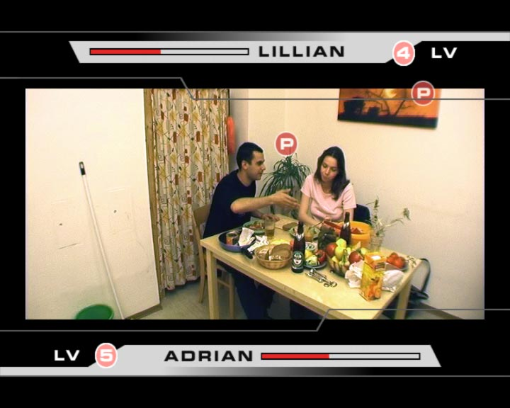
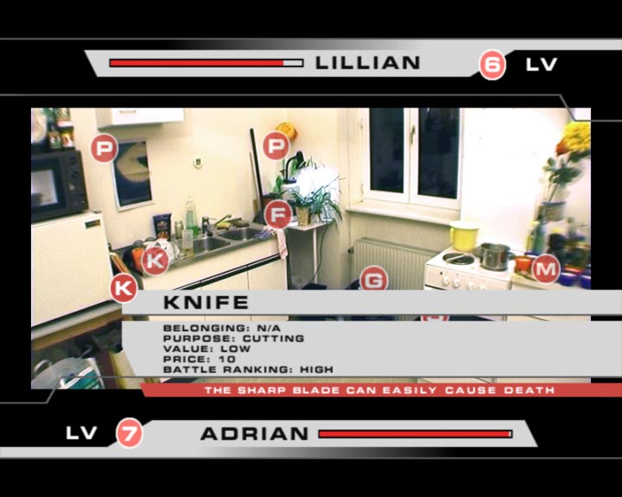

During a microwave defrost cycle, the harmless conversation of a couple sitting at a kitchen table develops into an argument which will seemingly explode at any moment. Framed by the graphic user interface of a video game and its animated graphics, which rate the emotional atmosphere and the significance of objects in the room with regard to the argument, the video`s image is increasingly shifted into a virtual context...
distribution / sixpackfilm
Harald Holba: *1977
Starts studying visual media at the university for applied arts in vienna in 1997. Completition of the course of visual media in summer 2004 with the degree of magister artium. Lives and works in vienna.

movie (selection):
BITCRUSHER / 11:20min, 2004
BUSTED 818 / 05:09min, 2002
POOL_2 / 04:57min, 2001
PLAN-C / 05:00min, 2001
RAUM 31 / 04:00min, 2000

http://www.holba02.at

